**Problem Statement:** Write a program using Arduino to control LED (One or more ON/OFF) Or Blinking

**Program:**

void setup()

{

pinMode(13, OUTPUT);

}

void loop()

{

digitalWrite(13, HIGH);

delay(1000); digitalWrite(13, LOW); delay(1000);

}

**For multiple LED’s**

4 led blinking

int ledPin1 = 2;

int ledPin2 = 3;

int ledPin3 = 4;

int ledPin4 = 5;

void setup()

{

pinMode(ledPin1, OUTPUT);

pinMode(ledPin2, OUTPUT);

pinMode(ledPin3, OUTPUT);

pinMode(ledPin4, OUTPUT);

}

void loop()

{

digitalWrite(ledPin1, HIGH);

digitalWrite(ledPin2, HIGH);

digitalWrite(ledPin3, HIGH);

digitalWrite(ledPin4, HIGH);

delay(1000);

digitalWrite(ledPin1, LOW);

digitalWrite(ledPin2, LOW);

digitalWrite(ledPin3, LOW);

digitalWrite(ledPin4, LOW);

delay(1000);

}

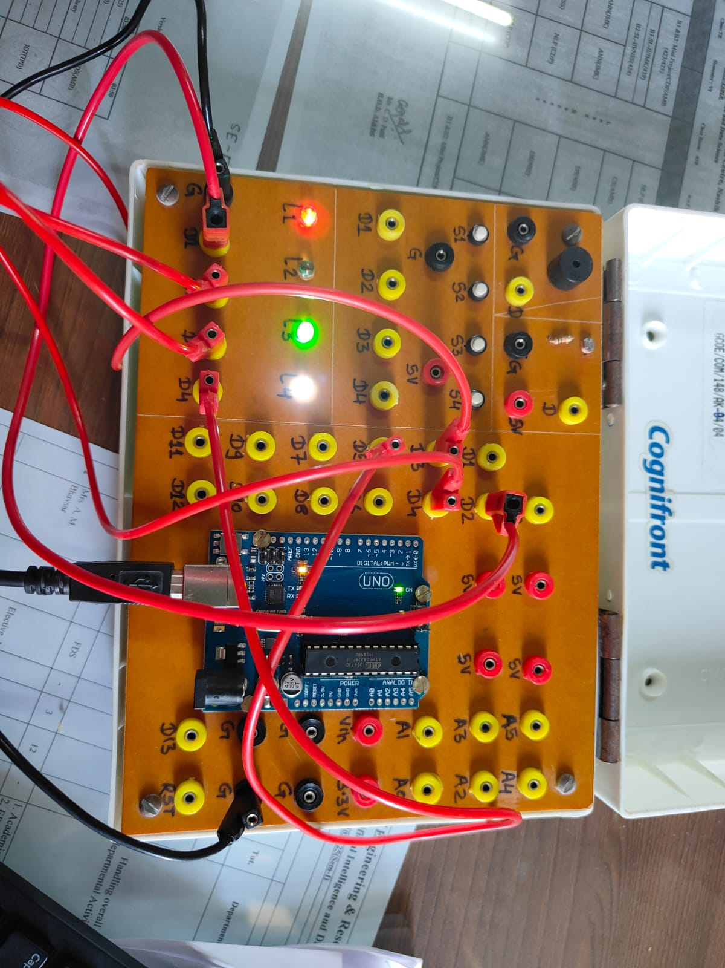

**Problem Statement:** Write a program that asks the user for a number and outputs the number squared that is entered

**Program Code:**

int out;

void setup()

{

Serial.begin(9600); // opens serial port, sets data rate to 9600 bps

}

void loop()

{

// send data only when you receive data:

if (Serial.available() > 0)

{

// read the incoming byte:

int num=Serial.readString().toInt();

// say what you got

Serial.print("I received: ");

Serial.println(num);

out = num*num;

Serial.print("Sq of no.: ");

Serial.println(out);

}

**Problem Statement:** Write a program read the temperature sensor and send the values to the serial monitor on the computer.

**PROGRAM CODE :**

#define DHTPIN 2

void setup()

{

Serial.begin(9600);

}

void loop()

{

int temperature = analogRead(DHTPIN);

Serial.print("Temperature is: ");

Serial.print(temperature);

Serial.println(" degree Fahrenheit ");

delay(2000);

}

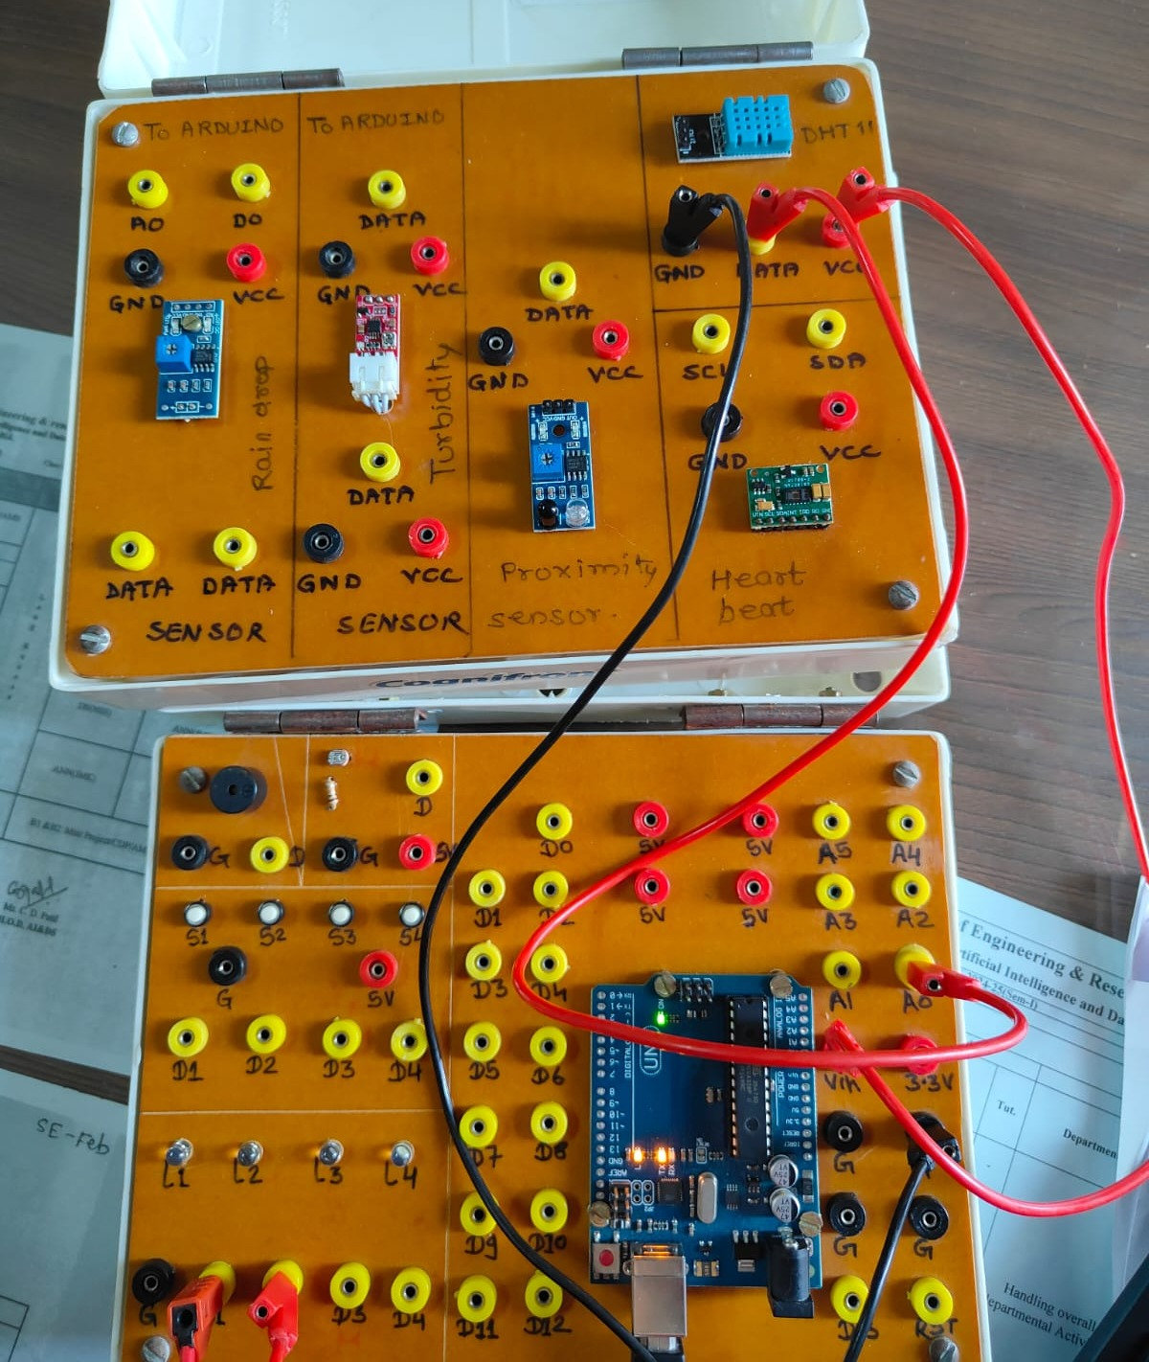

**Problem Statement = Write a program using piezo element and use it to play a tune after someone knocks**

int buzzerPin = 2; // Pin connected to the buzzer

void setup() {

pinMode(buzzerPin, OUTPUT); // Set the buzzer pin as an output

}

void loop() {

digitalWrite(buzzerPin, HIGH); // Turn the buzzer on

delay(1000); // Wait for 1 second

digitalWrite(buzzerPin, LOW); // Turn the buzzer off

delay(1000); // Wait for 1 second

}

**Problem Statement = Write a program using piezo element and use it to play a Multiple tune**

int buzzerPin = 2;

void setup() {

// Nothing to setup for this example

}

void loop() {

// Play the melody

tone(2, 3000, 500), delay (1000);

tone(2, 3100, 500), delay (1000);

tone(2, 3200, 500), delay (1000);

tone(2, 3300, 500), delay (1000);

tone(2, 3400, 500), delay (1000);

tone(2, 3500, 500), delay (1000);

tone(2, 3600, 500), delay (1000);

tone(2, 3700, 500), delay (1000) ; // Wait 1 second before repeating

}

